UHF_RFID_SDK

Quick Start Guide V1.0

**contents**

Support Devices List 1

UHF_RFID_SDK Introduce 2

Function 2

RFID Menu 3

Advanced Menu 4

Keyboard Mode 5

Broadcast Mode 5

UHF_RFID_SDKSample Introduce 5

UHF_RFID_SDK Usage 6

UHF_RFID_SDK Setting 6

Trigger Read NFC 8

Note 11

# **Support Devices List**

|  |  |
| --- | --- |
|  | FT230X |

# **UHF_RFID_SDK Introduce**

## **Function**

The UHF_RFID_SDK application is mainly used to simplify the development and use of RF SDKs by customers.

It integrates the functions of the FT230X module. It also provides broadcast triggering interface and floating button triggering mode for NFC recognition. The broadcast trigger interface cannot be closed and configured. It is mainly used for calling third-party applications. The floating button triggering mode can be configured and turned off.

In addition, there are two processing methods for the data read by UHF_RFID_SDK. One is to simulate keyboard input method, which directly converts scanned data into keyboard input data. The other is to forward scanned data in the form of broadcast so that third-party applications can receive the data.

Customers only need to make some simple configuration for UHF_RFID_SDK, so they can easily

use barcode scanner to collect data.

## **RFID Menu**

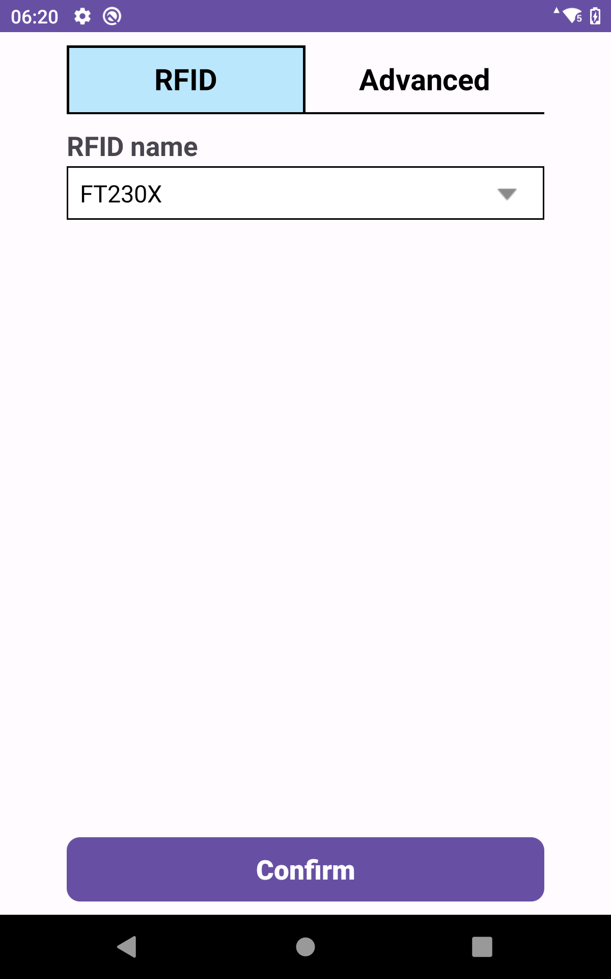

|  |  |
| --- | --- |
| **Name** | **Description** |
| RFID name | The RFID model name.  1、FT230X |

## **Advanced Menu**

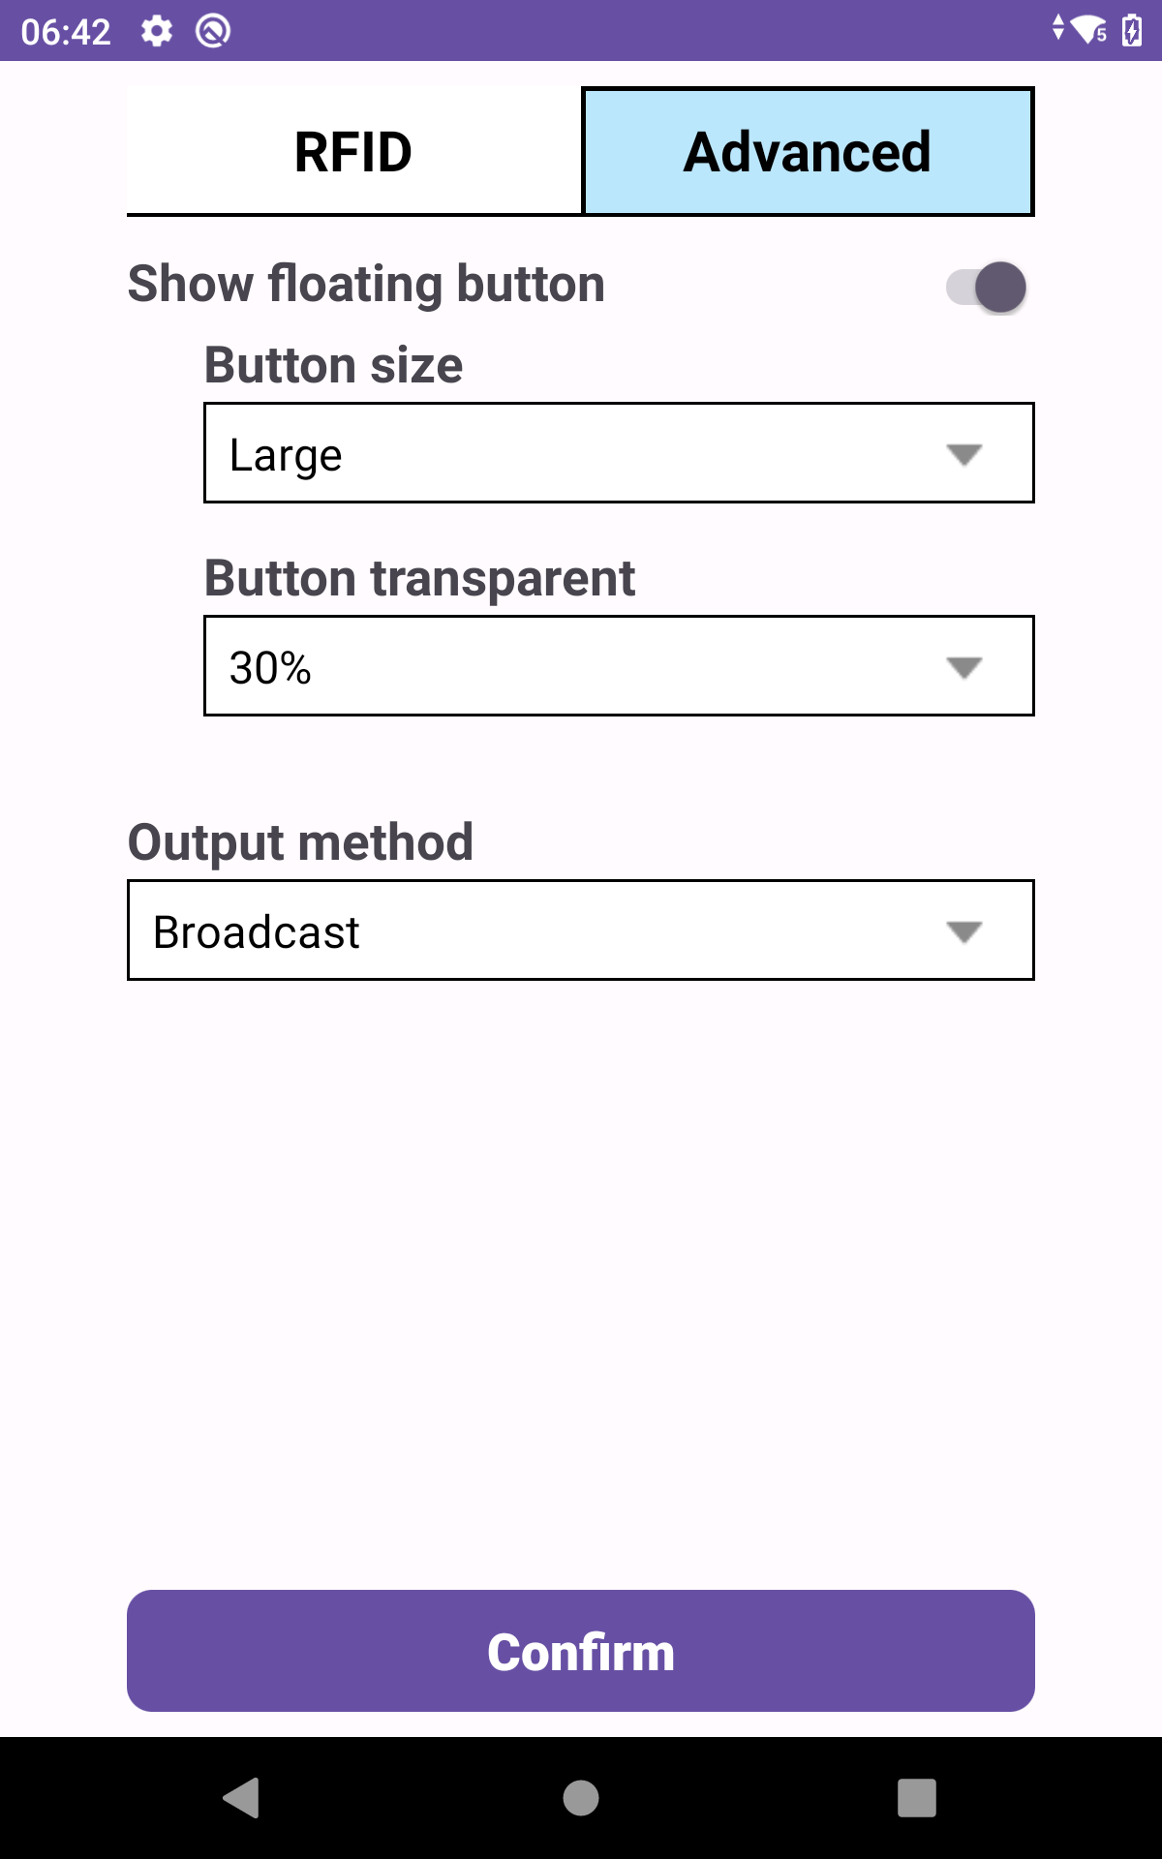

|  |  |
| --- | --- |
| **Name** | **Description** |
| Show floating  button  Button size | Determines whether to display the floating button  Size of floating button  1.Small  2.Normal  3.Large |
| Button transparent | Transparent of floating button  100%  90%  80%  70%  60%  50%  40%  30%  20%  10%  0% |
| Output Method | Set the flow direction of the scanned data.  1. Keyboard  2. Broadcast |

### Keyboard Mode

Keyboard mode is to send the read data to the system in the form of analog keyboard input.

In this mode, the scanned data will be directly filled into the edit box where the focus is located

### **Broadcast Mode**

Broadcast mode is to send the read data to the third-party app in the form of broadcast.If you want to get the data, you need to listen to the"com.advantech.uhf.rfid.TRANSFER_DATA" broadcast in the app, and get the data fromthe extra string "scan_data" after receiving the broadcast information. Please refer to UHF_RFID_SDKSample app source code for details.

# **UHF_RFID_SDKSample Introduce**

UHF_RFID_SDKSample is an open source sample app, which is mainly used to give users

reference on how to trigger a scan through broadcast and how to receive the scanned data

through broadcast.

# **UHF_RFID_SDK Usage**

## **UHF_RFID_SDK Setting**

Run UHF_RFID_SDK app and make some configuration

1. RFID name : Select the FT230X moudle



2. Show floating button: Select whether to turn it on according to your own needs. If enabled,

you can continue to configure the following parameters

1. Button size: Normal

2. Button transparent: 50%

3. Output method: Keyboard

4. Complete configuration(This step is indispensable)

Click the confirm button to complete the configuration



## **Trigger Read NFC**

There are two ways to trigger a scan

a. Broadcast trigger

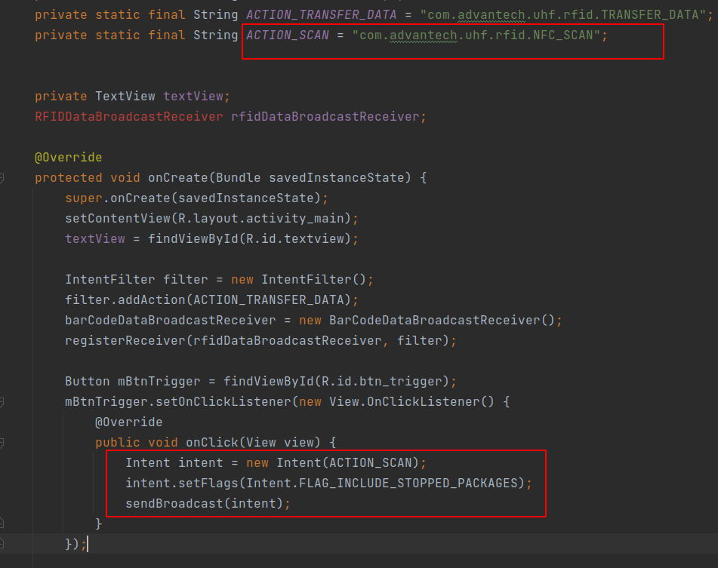

b. Floating button trigger

If you turn on the floating button, you can see the floating button shown below in the UI.

Click it to trigger scanning

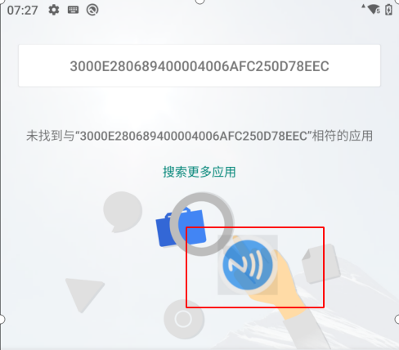

If broadcast mode is selected in “Advance->Output method”. You can add the following code to your app to receive data.

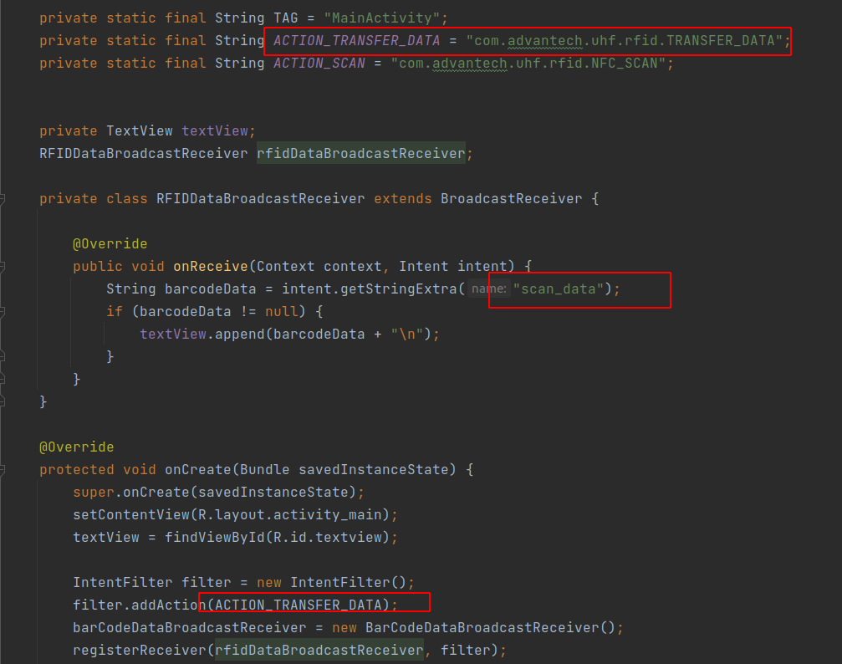

For example, the data received with UHF_RFID_SDKSample app is as follows

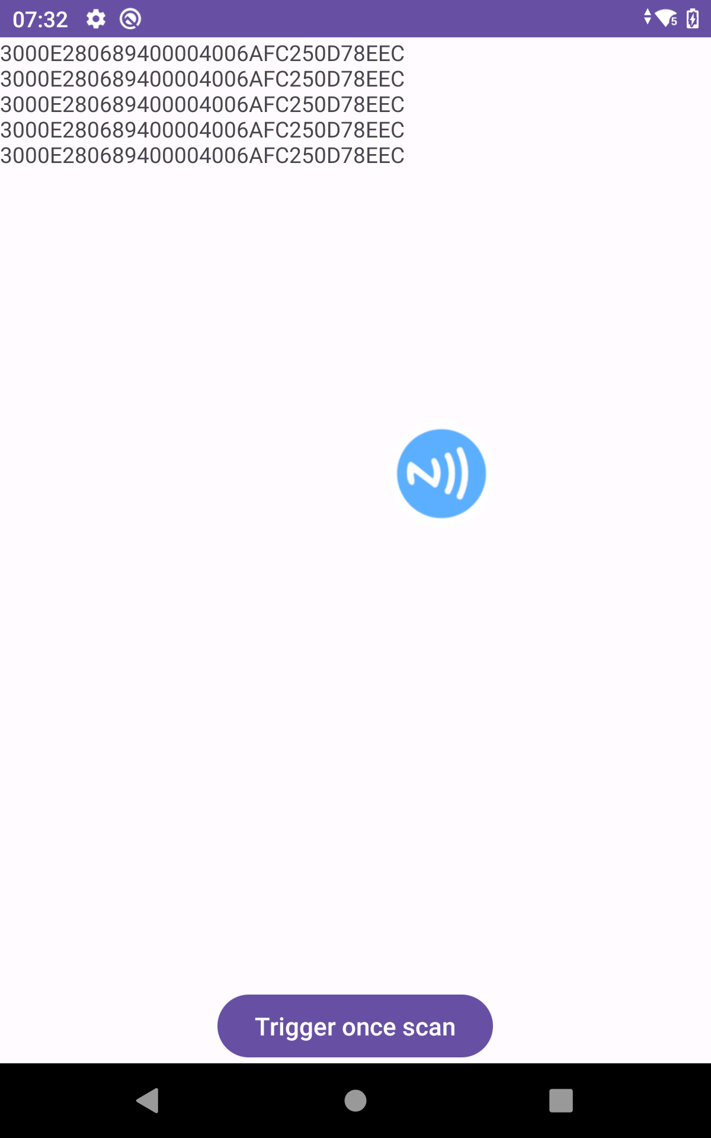

# **Note**

UHF_RFID_SDK app needs system signature, so please sign the app before installation.